ELIMUHUB TRIAL EXAMS
HOME SCIENCE ACTIVITIES
TERM 2 2021

NAME DATE

Strand/Sub strand | Questions | Total marks | Score | Performance Level
Healthy Living | 1-9 | 25
Consumer Education | 10 | 4
Foods and Nutrition | 11-13 | 15
Clothing | 14-15 | 6
TOTAL |  | 50
PERFORMANCE LEVEL GUIDELINES
Strand 2
5 scores = level 4
4 scores = level 3
3 scores = level 2
0-2 score = level 1

Strand 1
Strand 3
5 scores = level 4
4 scores = level 3
3 scores = level 2
0-2 score = level 1

15-20 scores = level 4
10-14 scores = level 3
7-9 scores= level 2
0-6 score = level 1
- List any two needs of a child for good growth (2 marks)

- Name two illnesses in your locality (2 marks)

- Identify 2 changes that take place during pre-adolescence (2 marks)

- Explain two factors you consider in choosing clothes for pre-teens (4 marks)

- Below are common ways of dressing in your locality
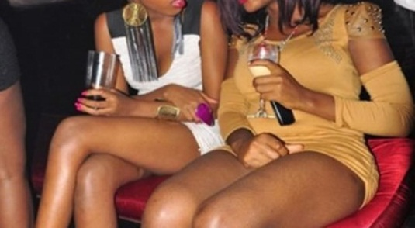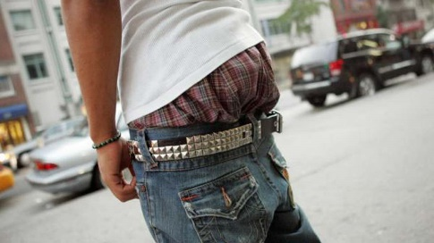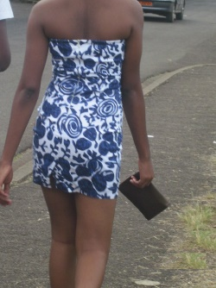
- What observation can you make from the above pictures (2 marks)

- As a Grade 5 learner what are the effects of such dressing to health. (2 marks)

- What factors did they omit while choosing their dresses? (2 marks)

- State any two items used for cleaning the home (2 marks)

- Name two methods you use in cleaning the home. (2 marks)

- Identify any 3 types of shoes in your locality (3 marks)

- Identify two types of fuels used at home. (2 marks)

- Discuss three things you may consider before buying food from a grocery (3 marks)

- State 2 reasons why we preserve milk (2 marks)

- What are some of fragile kitchen utensils that you know (4 marks)

- Your teacher will provide you with a dirty ceramic plate. Demonstrate the process of cleaning, drying and storing the ceramic plate. Observing safety while doing the process. (10 marks)

- Draw any two tools used in needlework. (2 marks)

- Explain 2 uses of stitches in clothing (4 marks)

MARKING SCHEME
- vitamins
Proteins
Carbohydrates
- malaria
Headache
Stomachache
- increase in size and length
Air growth in the pubic parts
Voice broadening in boys
- events- church clothes should be long and presentable to show respect
Gender- boy have different clothes to put on

- a)trouser shagged
Short dresses put one
b) Rape case for short dresses in girls
Immorality
- mopes
Brooms
Dusters

- sweeping
Dusting
Mopping
- leather shoes
Canvas shoes
Plastics shoes
- electricity
Kerosene
Natural gas
- cleanliness of the grocery
Expiry date of the items sold
Price
- to make it last longer
To protect it from germs and dirt’s
- ceramics
Thermos flask
Glasses
Pots
- award marks according to learners capability
- needles
Threads
- to strengthen clothes
add beauty to clothe

