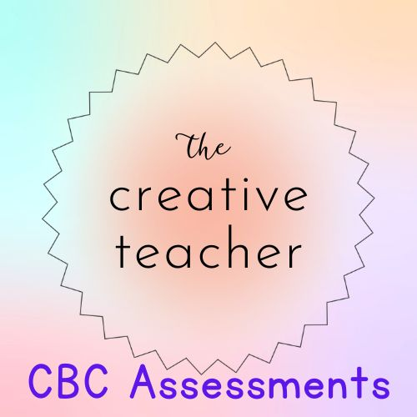
GRADE 4
MID TERM ASSESSMENT
TERM 1 2023
SCIENCE

Name:_________________________________________________
School:________________________________________________
Grade:________________________________________________
Gender: Boy _______________ Girl ______________
For official use only
TASK | Exceeding Expectation | Meeting Expectation | Approaching Expectation | Below Expectation
 | 24-25 | 17-23 | 11-16 | 0-10
SCIENCE

SCIENCE
1. Name five characteristics of animals. (5)
____________________________________________________________________________________
____________________________________________________________________________________
____________________________________________________________________________________
____________________________________________________________________________________
____________________________________________________________________________________
2. What are vertabrates? _________________________________________________________
__________________________________________________________________________________ (1)
3. Name two examples of veterbrates ___________________________________________
___________________________________________________________________________________(2)
4. What is the function of the mouth in the digestive system? _________________________ _______________________________________________________________________________________ (2)
5. What is the function of each tooth drawn below? (4)
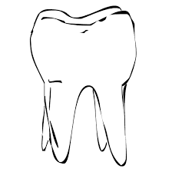__________________________________________________________________
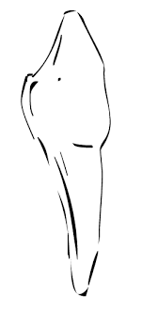______________________________________________________________________________
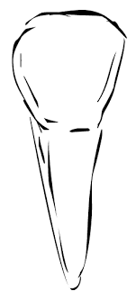_________________________________________________________________________________
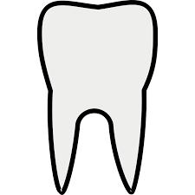_________________________________________________________________________
5. Name three air pollutants in the environment. (3)
________________________________________
________________________________________
________________________________________
6. Draw an air detector.

7. Name the parts of a desktop.


8. What is water filtering?
____________________________________________________________________________________________________________________________________________________________________________________(2)

